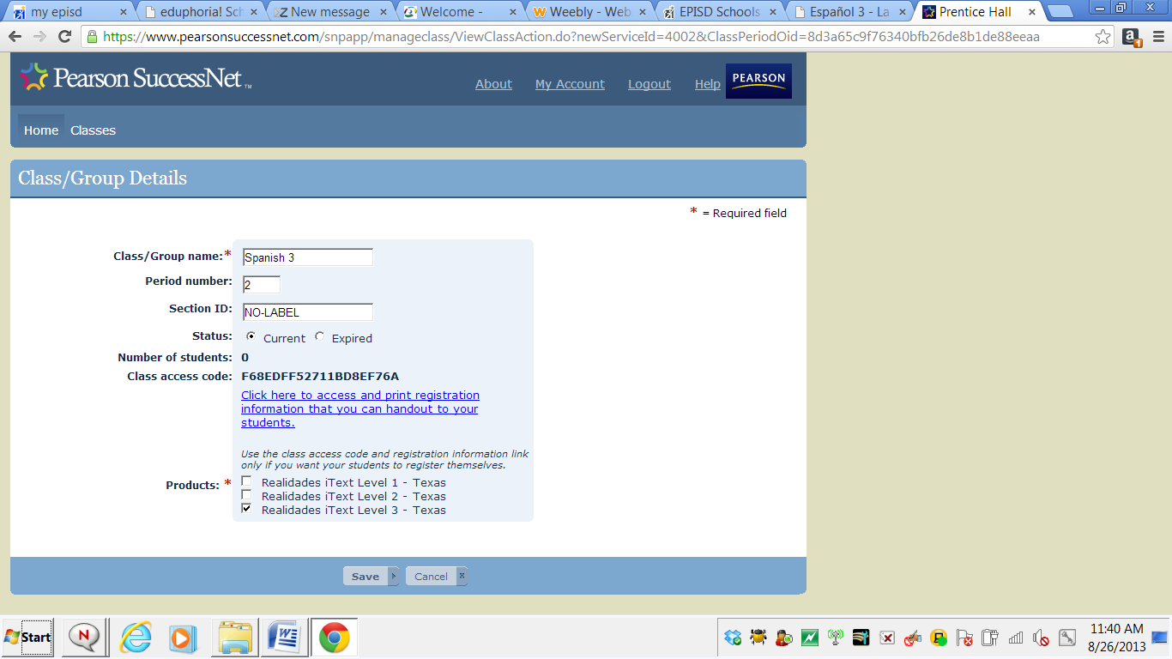
https://www.pearsonsuccessnet.com

